Q.1 seal and sealing of haddpan

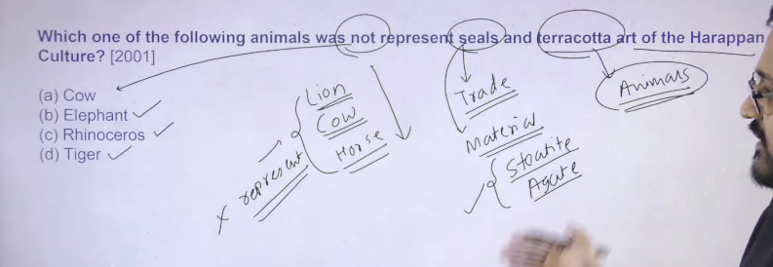

Ans: A

Seals signify trade and seal used on trade cartons they signify the large scale of trade of haddpan

Material is used on seal is steatite and agate there are two type of stoen which is used making of seal apart from those different type of material like gold , copper , bronze different type of material has also been used in order to make the seal

Terracotta figurines of different kind of animal has been discovered

There are two type of animal which are not present on haddapan seal Cow, Lion Horse these three animal does not represent on haddapan art different tpe of animal has been depicted but these animal has not like deere is there buffalo is there rhino is there elephant is there so thes type of different kind of animal has been depicted there

Then these aminal are something that is not represent on haddpan seal as well as art also

This is the basic information regarding seals and sealing of haddpan

2

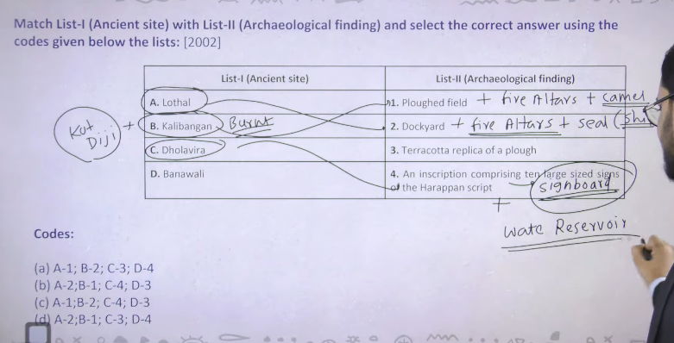

Lothal is quiet famoaus because of Dockyard +Fire altar +Seal(ship ) different type of ship are represented so ship boat is representd on lothal seal

so fire altar signify that there was some sort of religio is thee

Kalibangan- ploughed field + fire altars + bones of camel

Apart from this kalibang town is find as burn twon jala hua town and yaha se jail hue chudyia bhe mile ahi and ye haddpan town pura ka pura jala hua mila hai

Kotdiji= ye town bhe hume pura jala hua mila hai ye Pakistan me hai

Dholaveera – water reseivoire (tank) total 6 + se hume sign board mila hai dholaverea ke street ke uparr ek sign board mila hai

Dhola verea se hume 6 water reservioir mile hai inke beauty ye hai ki ye 6 ke 6 vo reservoir underground pipe line se ek dusre se connected haii water of one reservioir can be transferred to the another reservoir via using this underground pipe line

Jisse ye pata chalta hia key aha ek elaborate political centere hote hoge

3

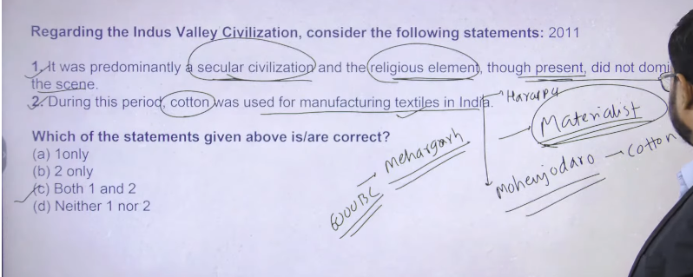

Indus valley civilization ko materialistic civilization bhe bola jata hai

Materialistic civilization ka matlab hota hai ke apke civilization me jo puja aur jine bhe religious element hai wo ku kyia jate ahi

There are two kind of puja ek puja bhakit aur moksh ke lyie hote hai jitney bhe sadhu sanyasi ya preiettsly class hai wo puja archana karta hua milega

Dusre puja puja matieralsitic chezao ke prapt ke lyei ya sansareek such ke prapte k lyie ke jate hai

So ultimate purpose of your life is something that determine character of your religioun means agar app dharm ke peechoe ho leking kudh ke material gain k lyie ho to wo materiasitc religion hoga aur agar apke civilization me maxiumum log yahe soch rakhte hai to app usko bologe materialsitc civilization

Like today ka india bhe materialsitc hai kuki hum jo puja archana karte hai wo world ke pleasure ko gain krne k lyie krte hai

1. Religious element hai wo socity me dikhente hai but uska utna society per asar nahi padta hai moksh is something that is secondary purpose so first statement is correct

2 cotton ka jo earliest evidence mila hai wo hum logo ko mehrgarsh (Pakistan ) 6000 BCE onward

By the time of haddpan civilization we can see that inke paas cotton textile tha ki haddapan ke jo toys the wo terracotta toys ke bante the jin per unhone kapde bhe pahna kr rakhe hai

Haddpan sse bahut sare spindle holes bhe mile hia jo kapde seene k lyie use hote the

Textile – means kapda

Mohnjado se hum eke cotton ka cloth bhe mila hai

Acorosss the Indus valeey civlizaiton joteracotta figure hai un per kapdo ke design bhee mile hai

4

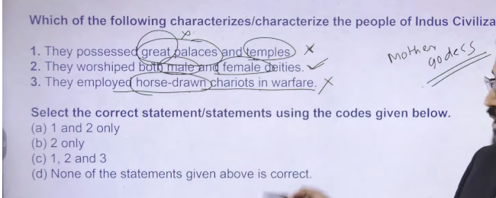

1. hum logo ko tmple and palaces mile hai but the extremist of th e statement negates the entire statement that jo temple and palace the wo great nhi the so hum logo ko temple and palace dono mile hai but wo great nhai the
2. so palaces were there and temple were there but greatness not found
3. worship mother goddess earliest mothere goddess element found from Neolithic settlement of mehrgarh
4. we have got the certain evidence of mother goddess on chaloclithc , neolithc and haddpan time
5. male worship is genetal of male
6. haddpan ke pahele Neolithic and chalogithci india n seletelemtn me wahah per hose ke evidence find hue hai but haddapna se hume horse kaoi koi evidence nhi mila hai it is still matter of debate so hadpan se hume lion and horse ke evidence nhai mile hai

5

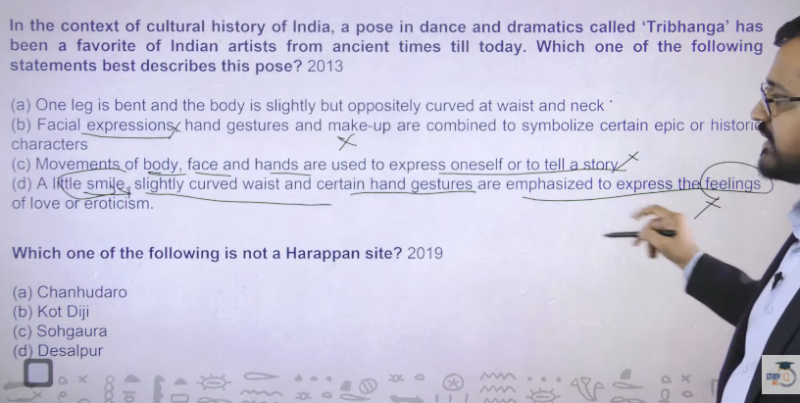

Ans: a

Trebangh basically three different bend in your body ek neck ke paas ek kamar waist and ek pair ke aroud hoga hum lgogo ko kek bronze dancing girl mile hai haddpan ke time ke in teen bend ko he treebangh mudra bolte hai haddpan period se ye trebangh mudra milne chalu hue hai

2 isme koi expression nahi ate hai bas teen bent ate hai eaariliest type sirf teen bend ka tha usme koi facial expression nahi tha medvial time me facial expression and different type of other fomr dalna chalu hua tha

Baad me treebangh mudra ke different version jo hai wo classical dance form of india me adopt kran chalu kr dyai

6

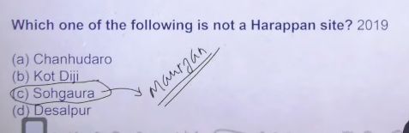

Sohgaruya is mauryan site

Isme local admistratin ko direct order dyia tha chandragutpa murya ne koshtagara ka means hai store of grain sohargaura se muaryan time ke inscription mila hai

Remaining are haddpan site

7

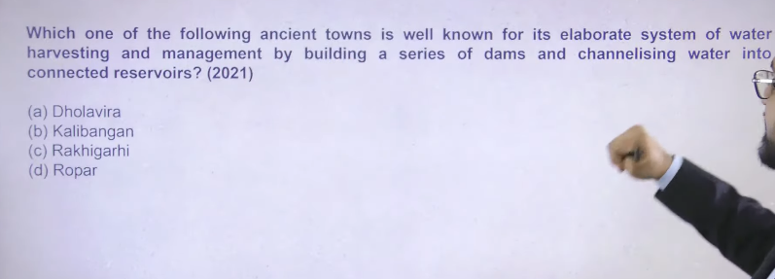

Dholavera me six different tank hai jisme undergourng water channel hai jo ek dusre ko connect krte hai

Ans:a

Haddapn town basically 2 folds me he divedid hai bahut kb town hai jaah per citadel middle and lower town classification milta hai

Like dholavera me 3 type ke town milte hai citadel , middle lower

General settlement pattern is onlye classified into tow part citadel and lower

Horse ka pura civilization me sirf ek jagah se he evidence mila hai wo hai surkotada ek he tukada mila raha hai bone ka

Same theory is for bronze plough

Vedic age

1

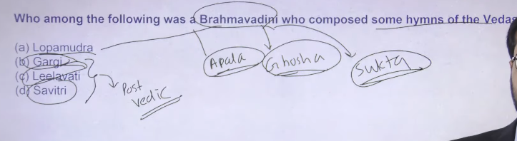

2

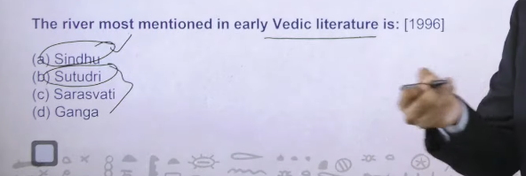

3

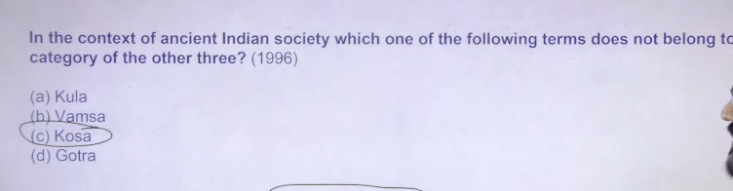

4

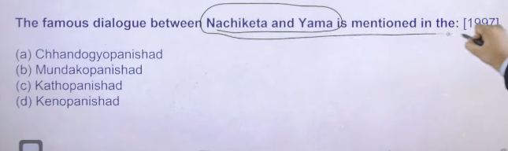

12

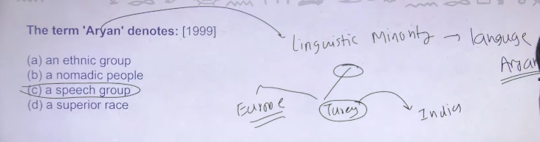

13

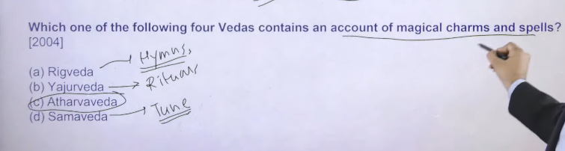

14

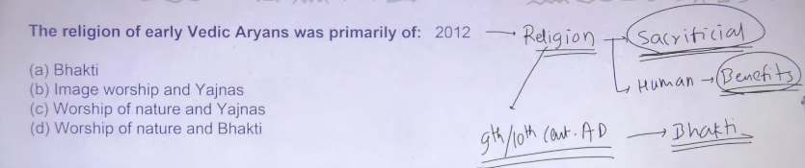

15

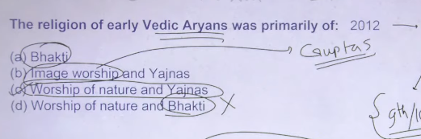

16

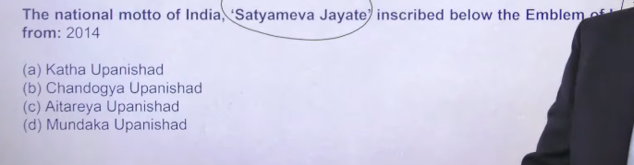

17

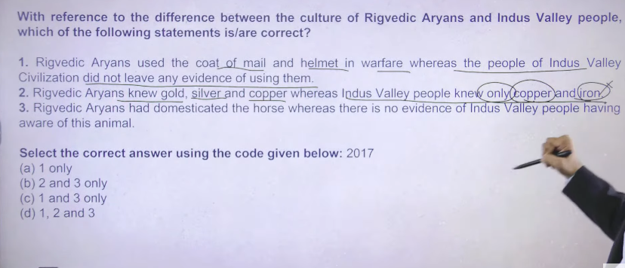

12

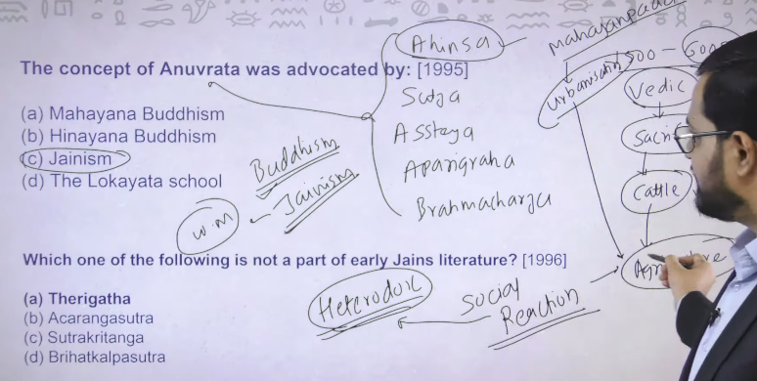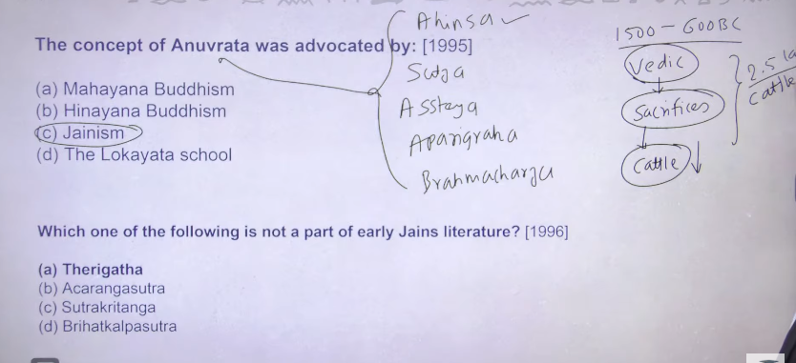

13